XXX Secondary School
20xx-20xx
Business, Accounting and Financial Studies
Basics of Accounting: Accounting Equation Note 2

Name: __________________ Class: _____ Class No: ____ Date: _________

2.2 Accounting Equation
A business aims to make profit (the revenues earned should be greater than the expenses incurred).
Revenues: _______________________________________________________

Expenses: _______________________________________________________

Revenues (R) | Expenses (E)

Revenues > Expenses => ________________
Revenues < Expenses => ________________

Assets (A) = Capital (C) + [Revenues (R) – Expenses (E)] + Liabilities (L)

Profit is ___________________ and Loss is _______________________.
Drawings: ___________________________________________________________
The amount of drawings would be ___________________________.

Assets (A) = Capital (C) + [Revenues (R) – Expenses (E)] – Drawings (D) + Liabilities (L)

=
+ Liabilities (L)

Capital (C)
+ [Revenues (R) – Expenses (E)]
– Drawings (D)
Assets (A)

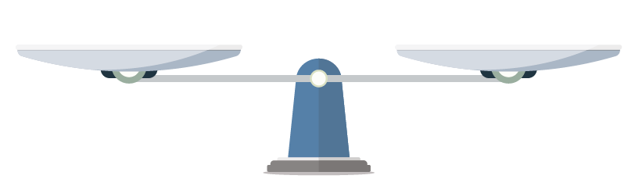
The total sum of a business owned (Assets) is equal to
the sum of the resources provided by the owner(s) (Capital) with deduction of taken/ withdrawal by owner(s) (Drawings) and addition of Profit (Revenues–Expenses), and
resources borrowed from others apart from the owner(s) (Liabilities).
The two sides of the equation must be the same and balanced.

Effects of Business Transactions on Accounting Equation
Analyzing the Effects of Business Transactions on the Accounting Equation

- identifying the items (accounts) and amount to be affected by the transaction
- double-checking which items (accounts) are to be affected at a time (at least two items)
- marking the effects of the transaction (increased, decreased or unchanged) on the relevant items of the accounting equation
- double-checking if the accounting equation remains balanced after marking the effects

Transactions | Assets | + | Expenses | + | Drawings | = | Capital | + | Revenues | + | Liabilities | Accounting Equation
- The firm paid salary $1,690 in cash.
- The firm received bank interest $2,400.
- The firm bought goods $4,500 from a supplier on credit.
- The firm sold goods $3,200 to customer on credit.
- The owner withdrew cash $2,000 for personal use.
Answers:

2.2 Accounting Equation
A business aims to make profit (the revenues earned should be greater than the expenses incurred).

Revenues: income earned from sales of goods or provision of services to customers

Expenses: costs incurred to generate revenue

Revenues (R) | Expenses (E)
Sales  Interest income  Commissions revenue | Salary  Rent  Electricity  Water fee  Utilities  Management fee

Revenues > Expenses => Profit
Revenues < Expenses => Loss

Assets (A) = Capital (C) + [Revenues (R) – Expenses (E)] + Liabilities (L)

Profit is added to Capital and Loss is deducted from Capital.
Drawings: resources of a business taken by its owner for personal use
The amount of drawings would be deducted from Capital.

Assets (A) = (Capital (C) + [Revenues (R) – Expenses (E)] – Drawings (D) + Liabilities (L)

=
+ Liabilities (L)

Capital (C)
+ [Revenues (R) – Expenses (E)]
– Drawings (D)
Assets (A)

The total sum of a business owned (Assets) is equal to
the sum of the resources provided by the owner(s) (Capital) with deduction of taken/ withdrawal by owner(s) (Drawings) and addition of Profit (Revenues–Expenses), and
resources borrowed from others apart from the owner(s) (Liabilities).
The two sides of the equation must be the same and balanced.

Effects of Business Transactions on Accounting Equation

Transactions | Assets | + | Expenses | + | Drawings | = | Capital | + | Revenues | + | Liabilities | Accounting Equation
- The firm paid salary $1,690 in cash. | ↓ $1,690 |  | ↑ $1,690 |  |  |  |  |  |  |  |  | Total unchanged and the equation remained balanced
- The firm received bank interest $2,400. | ↑ $2,400 |  |  |  |  |  |  |  | ↑ $2,400 |  |  | Total increased but the equation remained balanced
- The firm bought goods $4,500 from a supplier on credit. |  |  | ↑ $4,500 |  |  |  |  |  |  |  | ↑ $4,500 | Total increased but the equation remained balanced
- The firm sold goods $3,200 to customer on credit. | ↑ $3,200 |  |  |  |  |  |  |  | ↑ $3,200 |  |  | Total increased but the equation remained balanced
- The owner withdrew cash $2,000 for personal use. | ↓ $2,000 |  |  |  | ↑ $2,000 |  |  |  |  |  |  | Total unchanged and the equation remained balanced

